**PostgreSQL – Question & Answers**

**Question 1:**What is PostgreSQL, and how does it differ from other relational database management systems like MySQL?

**PostgreSQL** is an advanced, open-source relational database management system (RDBMS) that is designed to store, manage, and retrieve data efficiently. It is known for its robust feature set, including support for complex queries, foreign keys, triggers, and stored procedures. It is fully ACID-compliant (Atomicity, Consistency, Isolation, Durability), which ensures data integrity.  
**PostgreSQL** is an advanced, open-source relational database management system (RDBMS) that is designed to store, manage, and retrieve data efficiently. It is known for its robust feature set, including support for complex queries, foreign keys, triggers, and stored procedures. It is fully ACID-compliant (Atomicity, Consistency, Isolation, Durability), which ensures data integrity.

**Key Features of PostgreSQL:**

1. **ACID Compliance**: PostgreSQL ensures reliable transactions and data integrity.
2. **Advanced Data Types**: It supports a wide variety of data types, including custom types, arrays, and JSON.
3. **Extensibility**: You can add custom functions, data types, and extensions to PostgreSQL.
4. **Concurrency**: It uses Multi-Version Concurrency Control (MVCC) to handle multiple transactions simultaneously without conflicts.
5. **Standards Compliant**: It adheres to SQL standards and offers a rich set of SQL features.
6. **Replication & Clustering**: It supports synchronous and asynchronous replication, making it scalable for high-availability applications.
7. **Community-Driven**: PostgreSQL is maintained and updated by a large community of developers and users.

**PostgreSQL vs. MySQL**

1. **SQL Compliance**:
   * **PostgreSQL**: It is highly SQL-compliant and adheres strictly to ANSI SQL standards. It supports advanced SQL features such as Common Table Expressions (CTEs), Window Functions, and more.
   * **MySQL**: While MySQL also supports SQL, it doesn’t fully comply with all SQL standards. It tends to have fewer advanced SQL features compared to PostgreSQL.
2. **Data Types**:
   * **PostgreSQL**: It has rich support for advanced data types like JSONB, hstore, custom types, arrays, and more. This flexibility makes it suitable for complex applications.
   * **MySQL**: Although it supports basic types like JSON, it doesn't have the same depth of support for complex or custom types as PostgreSQL.
3. **Performance**:
   * **PostgreSQL**: It generally provides better performance for complex queries and large databases due to its superior handling of indexing, concurrency, and optimization strategies.
   * **MySQL**: Typically performs better for read-heavy operations and simpler queries, making it ideal for websites or applications with a high volume of simple requests.

**Question 2:**What are the key features of PostgreSQL that makes it popular choice for storing and managing large datasets?

PostgreSQL is a popular choice for storing and managing large datasets due to its powerful features that ensure performance, scalability, data integrity, and flexibility. Here are the key features that make PostgreSQL stand out in handling large datasets:  
  
**1. ACID Compliance:**

PostgreSQL is fully ACID-compliant, ensuring **Atomicity**, **Consistency**, **Isolation**, and **Durability**. This guarantees the integrity of data, especially in scenarios where multiple users or applications are interacting with the database simultaneously. ACID compliance is crucial for large datasets to ensure that transactions are processed reliably and safely.

**2. MVCC (Multi-Version Concurrency Control):**

PostgreSQL uses MVCC to handle high levels of concurrency. This means multiple transactions can be processed simultaneously without affecting each other. MVCC allows **non-blocking reads** and ensures that data is consistent even under heavy load. This feature is particularly important when dealing with large datasets in high-concurrency environments.

**3. Advanced Indexing:**

PostgreSQL supports various types of **indexes** (B-tree, hash, GiST, GIN, and BRIN), which allow for efficient querying of large datasets.

* **BRIN (Block Range INdexes)**: Optimized for large datasets, particularly when the data is naturally ordered, such as in time-series data.
* **GIN (Generalized Inverted Indexes)**: Used for indexing composite or array data types, such as JSONB, enabling efficient full-text searches and querying of complex data.
* **GiST (Generalized Search Tree)**: A flexible indexing mechanism for geometric, network, and other complex data types.

**4. Partitioning:**

PostgreSQL supports **table partitioning**, which allows you to split large tables into smaller, more manageable pieces, improving query performance and maintenance. This feature is particularly useful for datasets that grow over time (e.g., time-series data, log data, or transactional data).

* **Range Partitioning**: Partitioning based on a specific range of values, such as dates or numeric ranges.
* **List Partitioning**: Partitioning based on discrete values, such as categories or regions.
* **Hash Partitioning**: Even distribution of data across partitions based on a hash function.

**5. Foreign Keys and Constraints:**

PostgreSQL supports advanced **referential integrity** with foreign keys and constraints. It ensures that data remains consistent across related tables, which is critical for managing large datasets that span multiple tables. These features help prevent data anomalies and improve data quality, which is essential when dealing with massive amounts of interconnected data.

**Question 3:**How does PostgreSQL implement transactions, and what are the benefits of using transaction in a database?

PostgreSQL implements transactions using the **ACID** properties (Atomicity, Consistency, Isolation, Durability) to ensure that database operations are handled reliably and that data integrity is maintained. Here's how each of these properties is implemented:

**1. Atomicity:**

* **Atomicity** ensures that all operations in a transaction are treated as a single unit, meaning either all operations are executed successfully, or none are. If an error occurs during a transaction, the database will roll back all changes made so far, ensuring the database is left in a consistent state.
* In PostgreSQL, atomicity is achieved using **write-ahead logging (WAL)**. Before any changes are made to the actual data, PostgreSQL writes a log entry to a WAL file. If a transaction fails, PostgreSQL uses the WAL to revert all changes, ensuring atomicity.

**2. Consistency:**

* **Consistency** ensures that a transaction brings the database from one valid state to another, maintaining all integrity constraints, such as foreign keys, checks, and triggers.
* PostgreSQL ensures consistency by enforcing rules defined in the schema (e.g., foreign key constraints, not-null constraints) and through the application of transaction rules, preventing the database from reaching an invalid state during the execution of a transaction.

**3. Isolation:**

* **Isolation** ensures that transactions are executed in isolation from one another, preventing concurrent transactions from interfering with each other. In PostgreSQL, the isolation level of a transaction can be controlled, allowing for different levels of concurrency control.
* PostgreSQL supports multiple **isolation levels**:
  + **Read Uncommitted** (lowest level): Allows dirty reads (transactions can read uncommitted changes from other transactions).
  + **Read Committed** (default): A transaction sees only committed changes made before it starts or during its execution but not changes made by concurrent transactions.
  + **Repeatable Read**: Guarantees that if a transaction reads a value, it will always see the same value throughout the transaction, even if other transactions modify the data.
  + **Serializable** (highest level): Provides the strictest isolation, ensuring transactions behave as if they were executed serially, one after another, without any concurrent execution.

**4. Durability:**

* **Durability** ensures that once a transaction is committed, its changes are permanent and will not be lost, even in the case of a system crash.
* PostgreSQL achieves durability through its **write-ahead logging (WAL)** system. Once a transaction is committed, changes are written to the WAL, which ensures that all committed transactions are recoverable in case of a failure.

**Benefits of Using Transactions in a Database**

Transactions provide several important benefits that ensure data consistency, reliability, and integrity:

**1. Data Integrity:**

* Transactions help maintain the integrity of the database by ensuring that either all operations within the transaction are executed successfully, or none are. This prevents partial or inconsistent data states, which could occur if some changes were applied and others were not.

**2. Consistency:**

* By ensuring that transactions follow the rules defined in the schema (like foreign key constraints), transactions prevent the database from entering an invalid state. This is particularly important when multiple operations need to be performed together (e.g., transferring funds between accounts), as it guarantees that all changes are applied consistently.

**3. Concurrency Control:**

* Transactions allow multiple users to interact with the database concurrently without causing conflicts. PostgreSQL's support for different isolation levels provides flexibility in managing concurrency, balancing the need for performance and the level of isolation required by different types of transactions.

**4. Rollback Capabilities:**

* If a transaction encounters an error or needs to be aborted, PostgreSQL allows for **rollback**. This ensures that no partial changes are left in the database, preventing corruption or inconsistent states. This is critical for long-running operations or complex processes that may fail at some point.

**5. Improved Performance with Isolation:**

* By grouping multiple operations into a single transaction, database systems can optimize execution and ensure that the system is not locked by other processes. For example, in **serializable** isolation level, although transactions execute in isolation, they can still be optimized in terms of performance by using techniques like **MVCC** (Multi-Version Concurrency Control) to avoid unnecessary locking.

**Question 4:**What is the differences between a PostgreSQL database and a schema, and how are they related?

In PostgreSQL, **database** and **schema** are related but distinct concepts. Here’s a breakdown of the differences between the two, as well as how they are related:

**1. PostgreSQL Database:**

* **Definition**: A PostgreSQL **database** is a collection of data stored in a structured format. It is a separate, isolated storage unit within the PostgreSQL system that holds all the data, tables, indexes, views, functions, and more. A single PostgreSQL instance can contain multiple databases.
* **Scope**: A database is a higher-level container for all objects. It is the largest unit of isolation and resource management in PostgreSQL. Each database has its own set of tables, views, and other objects, and each one operates independently.
* **Usage**: You would typically create a database to store the data for a specific application or system. For example, you might have a database for your "Online Store" or "Employee Management System."
* **Creation**: In PostgreSQL, you create a new database using the following command:

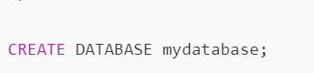  
  
  
**Example**: If you have a PostgreSQL instance running, you can have databases such as:

* myapp_db (for your application)
* test_db (for testing purposes)
* analytics_db (for storing analytic data)

**2. PostgreSQL Schema:**

* **Definition**: A **schema** in PostgreSQL is a logical container within a database that holds database objects such as tables, views, indexes, and functions. Schemas allow for organization and grouping of objects inside a database, which helps with managing large and complex systems.
* **Scope**: Schemas are nested within databases. While a database contains all the data and structures, a schema helps organize these structures into separate namespaces. A schema is essentially a way to group and organize database objects in a database.
* **Usage**: Schemas are useful when you want to organize tables and other database objects based on different modules, users, or applications within a database. For example, you might use one schema for "sales" data and another for "inventory" data, both within the same database.
* **Creation**: In PostgreSQL, you create a new schema using the following command:

**Example**: A single database might have several schemas:

* public (default schema where most objects are created)
* sales (for tables and views related to sales)
* inventory (for tables related to inventory management)

**Key Differences Between Database and Schema:  
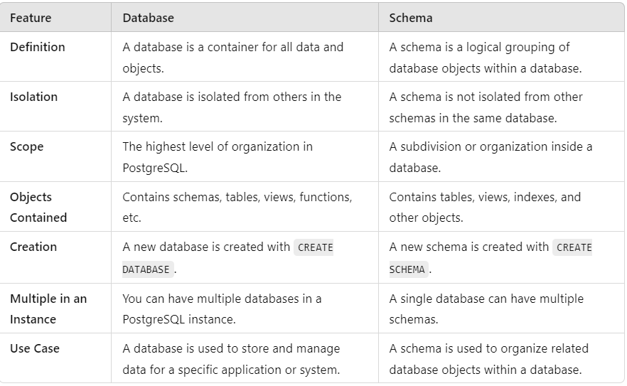  
  
  
How They Are Related:**

* A schema exists within a database. While a database is a container that holds data and other objects, a schema organizes the objects within that database. For example, if you have a database named mydatabase, you can create schemas within it such as public, sales, or inventory.
* Namespace: Schemas act as namespaces, ensuring that objects within the same database can have the same name without conflict. For instance, you could have two tables named orders, one in the sales schema and another in the inventory schema, and they would not conflict because they reside in different schemas within the same database.
* Access Control: PostgreSQL also allows setting permissions at the schema level. You can grant or revoke privileges to users for specific schemas, providing an additional layer of control over who can access which parts of the data in a database.

**Question 5:**What?